Software Requirements Specification for Project
Version 1.0 approved
Prepared by
HENIL VASANI (21SOECE11065)
JAY PIPARIYA (21SOECE11058)
JAY VIRANI (21SOECE11066)
<organization :- RK University >
<date created :- 23-02-2024>

Table of Contents
Table of Contents ii
1. Introduction 1
1.1 Purpose 1
1.2 Document Conventions 1
1.3 Intended Audience and Reading Suggestions 1
1.4 Project Scope 1
1.5 References 1
2. Overall Description 2
2.1 Product Perspective 2
2.2 Product Features 2
2.3 User Classes and Characteristics 2
2.4 Operating Environment 2
2.5 Design and Implementation Constraints 2
2.6 User Documentation 2
2.7 Assumptions and Dependencies 3
3. System Features 3
3.1 System Feature 1 3
3.2 System Feature 2 (and so on) 4
4. External Interface Requirements 4
4.1 User Interfaces 4
4.2 Hardware Interfaces 4
4.3 Software Interfaces 4
4.4 Communications Interfaces 4
5. Other Nonfunctional Requirements 5
5.1 Performance Requirements 5
5.2 Safety Requirements 5
5.3 Security Requirements 5
5.4 Software Quality Attributes 5

Introduction

Purpose
Integrating live cricket score updates into a React application can enhance its appeal to cricket fans, providing them with real-time information and keeping them engaged with the latest developments in the sport. Leveraging React's component-based architecture and state management capabilities, developers can create dynamic and interactive interfaces that seamlessly display live scores from ongoing matches.

.Document Conventions

When documenting a React application that integrates live cricket scores, it's important to establish clear conventions to ensure consistency and readability. Here are some document conventions specifically tailored for documenting a React-based live cricket score application

API Integration

Component Props

Component Structure.

Intended Audience and Reading Suggestions

When designing a live cricket score application in React, it's crucial to consider your intended audience and provide reading suggestions that enhance their experience. Here's how you can approach this:

Intended Audienc

Reading Suggestions

User Engagement

References

Project Refrence

https://crex.live/

Overall Description

Product Perspective
When considering the product perspective for a live cricket score application developed in React, it's essential to understand its context within the broader ecosystem

- Cricket Enthusiasts: Identify the primary audience as cricket fans ranging from casual viewers to avid followers.
- Demographics: Understand the demographics of your target audience, including age groups, geographic locations, and level of cricket knowledge.
- User Preferences: Analyze user preferences regarding features, user interface design, and content presentation

Product Features
- Real-time Updates: Provide live scores, ball-by-ball commentary, and match statistics to keep users informed during ongoing matches.
- Match Schedule: Display upcoming matches with details such as date, time, venue, and participating teams.
- Player Profiles: Offer information about players, including their profiles, recent performances, and career statistics.
- Team Stats: Include team statistics, head-to-head records, and rankings to provide context for matches.
- Notifications: Implement push notifications for important match events, match reminders, and personalized updates.
- Multimedia Content: Integrate photos, videos, and highlights to enhance the user experience and engagement.
- Social Sharing: Enable users to share scores, match updates, and memorable moments on social media platforms.
- Customization: Allow users to customize their experience by selecting favorite teams, players, and notification preferences.
.

Operating Environment

2.3.1 Operating System : The operating environment for a cricket live score application developed in React language encompasses various components that ensure its proper functioning and performance

- Database Management System (DBMS): Choose a suitable DBMS for storing and managing application data, including user preferences, match schedules, and historical statistics.
- MongoDB: MongoDB, a NoSQL database, can be used for its flexibility and scalability, especially for handling unstructured or semi-structured data such as match updates and user preferences.
- MySQL/PostgreSQL: For structured data requirements, traditional relational databases like MySQL or PostgreSQL may be preferred, offering robust transaction support and data consistency.

By ensuring a robust operating environment encompassing frontend and backend technologies, data sources, hosting infrastructure, performance monitoring, and security measures, the cricket live score application can deliver a reliable, high-performance, and secure user experience to cricket enthusiasts.

2.4 Design and Implementation Constraints
When developing a cricket live score application in React, you may encounter various design and implementation constraints that influence the development process. Here are some common constraints and considerations:

2.4.1. Data Source Limitations:
- API Restrictions: The availability and limitations of cricket data APIs may constrain the frequency of data updates, the granularity of information provided, and the types of data accessible.
- Data Quality: Inconsistent or inaccurate data from external sources can impact the reliability and accuracy of live scores and match statistics.

Real-time Updates:
- WebSocket Support: Implementing real-time updates for live scores and match events may require WebSocket support on the backend and integration with WebSocket libraries or services in the frontend.
- Server Load: Continuous real-time updates can impose significant server load, requiring efficient handling of concurrent connections and data processing.

Security and Privacy:
- Data Privacy Regulations: Ensure compliance with data privacy regulations such as GDPR (General Data Protection Regulation) or CCPA (California Consumer Privacy Act) when handling user data and personal information.
- Secure Authentication: Implement secure authentication mechanisms to protect user accounts and prevent unauthorized access to sensitive features or data.

By identifying and addressing these design and implementation constraints early in the development process, you can mitigate risks, optimize performance, and deliver a robust cricket live score application that meets user expectations and business requirements.

User Documentation

System Overview

Welcome to the Live Cricket Score Application! This documentation provides an overview of the application's features and guides you on how to use them efficiently.

InstallationAccount

Creation (Optional)

Features Overview

1. Live Scores
- View real-time updates of ongoing cricket matches, including scores, overs, wickets, and other match statistics.
- Click on a specific match to access detailed information such as team line-ups, player stats, and commentary.

2. Match Schedule
- Explore upcoming cricket matches with details such as date, time, venue, and participating teams.
- Set reminders for matches you don't want to miss by clicking on the "Remind Me" button.

3. Player Profiles
- Learn more about your favorite cricket players by accessing their profiles, including bio, career statistics, recent performances, and achievements.

4. Team Stats
- Check out team statistics, head-to-head records, rankings, and performance trends to gain insights into team matchups and form.

5. Notifications
- Receive push notifications for important match events, match reminders, and personalized updates based on your preferences.

6. Customization
- Personalize your experience by selecting favorite teams, players, and notification preferences.
- Access your customized content quickly from the dashboard or navigation menu.

Troubleshooting
- Clear Cache: Clear your browser's cache and cookies to resolve any caching issues.
- Check Internet Connection: Ensure you have a stable internet connection to receive real-time updates.
- Update Browser: Make sure you are using the latest version of your web browser for optimal performance.

Feedback and Support
We value your feedback! If you have any suggestions, questions, or encounter any issues while using the application, please don't hesitate to contact our support team at
@crex.live/feedback

Assumptions and Dependencies
When developing a live cricket score application in React, it's important to outline the assumptions and dependencies that will guide the development process and ensure smooth integration with external services. Here's a breakdown of assumptions and dependencies:

Assumptions:
- Availability of Cricket Data APIs: Assumes the availability of reliable and up-to-date cricket data APIs that provide live scores, match information, player statistics, and other relevant data.
- User Access to Internet: Assumes that users will have access to a stable internet connection to fetch live scores and updates in real-time.
- Supported Devices: Assumes that the application will be accessible on various devices, including desktops, laptops, tablets, and smartphones, with responsive design for optimal viewing experience.
- Legal Compliance: Assumes compliance with legal regulations and licensing agreements regarding the use of cricket-related data, including copyright, intellectual property rights, and data privacy laws.
- User Engagement Expectation: Assumes that users are interested in accessing live cricket scores, match schedules, player profiles, and related statistics, and the application aims to provide an engaging and user-friendly experience.

Dependencies:
- External APIs: Dependency on third-party cricket data APIs to fetch live scores, match information, player profiles, and other cricket-related data.
- React Libraries and Components: Dependency on React ecosystem libraries, components, and frameworks for building user interfaces, managing state, and handling routing within the application.
- Backend Services: Dependency on backend services for authentication, user management, and fetching additional data that cannot be obtained directly from external APIs.
- Database System: Dependency on a database system (e.g., MongoDB, MySQL) for storing user preferences, application settings, and caching data for improved performance.
- Web Server: Dependency on a web server to host the React application and serve static assets, handle HTTP requests, and manage routing.
- Authentication Services: Dependency on authentication services (e.g., JWT, OAuth) for securely authenticating users and managing user sessions within the application.
- Push Notification Services: Dependency on push notification services (e.g., Firebase Cloud Messaging, Pusher) to deliver real-time updates and notifications to users' devices.
- Development Tools: Dependency on development tools such as code editors, version control systems (e.g., Git), and package managers (e.g., npm, yarn) for collaborative development and managing project dependencies.
- Deployment Platforms: Dependency on deployment platforms (e.g., AWS, Heroku, Netlify) for deploying the React application to production environments and managing scalability, reliability, and performance.
- Testing Frameworks: Dependency on testing frameworks (e.g., Jest, React Testing Library) for writing and executing unit tests, integration tests, and end-to-end tests to ensure application quality and reliability.
By identifying these assumptions and dependencies upfront, you can better plan and manage the development process, prioritize tasks, and ensure successful integration with external services and systems while building the live cricket score application in React.

External Interface Requirements

User Interfaces

1. Homepage:
- Live Scores Section: Display a list of ongoing matches with live scores, indicating teams, current scores, overs, and wickets.
- Match Schedule Section: Present upcoming matches with date, time, teams, and venue information.

2. Match Details Page:
- Scorecard: Show a detailed scorecard with inning-wise scores, batsmen details, bowler stats, fall of wickets, and extras.
- Ball-by-Ball Commentary: Provide live commentary updates alongside the scorecard for a comprehensive match overview.
- Player Profiles: Link to player profiles for quick access to player statistics, bio, and recent performances.

3. Navigation Bar:
- Home: Direct users to the homepage with live scores and match schedule.
- Matches: Navigate to a page listing all matches, including ongoing, completed, and upcoming fixtures.
- Teams: Browse through teams participating in various leagues or tournaments, with links to team profiles.
- Settings: Access user settings for customization options, notification preferences, and account management.

4. Match Schedule Page:
- Calendar View: Present matches in a calendar view, allowing users to browse matches by date and view match details.
- Filtering Options: Enable users to filter matches by league, tournament, teams, or venue for easier navigation.

5. Player Profile Page:
- Player Bio: Display player information, including name, photo, nationality, role, and playing style.
- Career Stats: Showcase career statistics such as total runs scored, wickets taken, batting average, bowling average, and strike rate.
- Recent Performances: Highlight recent performances, milestones achieved, and notable achievements.

6. Notification Center:
- Push Notifications: Notify users about match updates, important events (e.g., milestones, wickets, boundaries), and personalized alerts.
- Notification Settings: Allow users to customize notification preferences based on their interests and favorite teams/players.

7. Customization Options:
- Favorite Teams/Players: Enable users to mark their favorite teams and players for quick access to relevant match information.
- Theme Selection: Provide theme options (light/dark mode) for personalized visual preferences.

8. Miscellaneous:
- Search Bar: Allow users to search for matches, teams, players, or specific events within the application.
- Footer: Include links to legal information, terms of service, privacy policy, and contact details.

9. Responsive Design:
- Ensure the UI is responsive and optimized for various devices and screen sizes, including desktops, tablets, and smartphones, for a consistent user experience across platforms.

10. Interactive Elements:
- Implement interactive elements such as buttons, dropdowns, sliders, and modals to enhance user engagement and facilitate navigation.
By incorporating these UI components and features, you can create a dynamic and user-friendly live cricket score application in React that meets the needs of cricket enthusiasts and provides an immersive match-watching experience.

Hardware Interfaces

Device Compatibility:
- Ensure that the application's user interface is responsive and compatible with a wide range of devices, including desktops, laptops, tablets, and smartphones.
.

Browser Support:
- Test the application across various web browsers (e.g., Chrome, Firefox, Safari, Edge) to ensure compatibility and consistent performance.

Accessibility:
- Ensure that the application is accessible to users with disabilities by following best practices for web accessibility (e.g., WCAG guidelines).

Software Interfaces

Cricket Data APIs:
- Integrate with cricket data APIs to fetch live scores, match schedules, player statistics, and other relevant information.
- Ensure compatibility with APIs provided by authorized data providers or cricket leagues, adhering to their usage guidelines and terms of service.

2. Authentication and Authorization Services:
- Implement authentication and authorization mechanisms to secure user accounts and restrict access to certain features or data.
- Utilize authentication services such as JWT (JSON Web Tokens) or OAuth for user authentication and session management.

3. Database Management System (DBMS):
- Interface with a database management system (e.g., MongoDB, MySQL) to store and manage application data, including user preferences, match schedules, and cached information.
- Design database schemas and queries to efficiently store and retrieve data for seamless application performance.

4. Backend Services:
- Communicate with backend services for business logic, data processing, and additional functionalities that cannot be handled on the client-side.
- Define API endpoints and protocols for frontend-backend communication, following RESTful principles or GraphQL for efficient data exchange.

Communications Interfaces

1. Cricket Data APIs:
- Requesting Live Scores: Interface with cricket data APIs to request live scores, match details, player statistics, and other relevant information in real-time.
- Data Format: Communicate with APIs using standard data formats such as JSON or XML and handle responses appropriately within the React application.

2. WebSocket Communication:
- Real-time Updates: Establish WebSocket connections to receive real-time updates and notifications for ongoing cricket matches.
- Subscription Mechanism: Implement subscription mechanisms to subscribe to specific match events or channels and receive instant updates as they occur.

3. RESTful API Endpoints:
- Backend Communication: Communicate with backend services through RESTful API endpoints to perform operations such as user authentication, data retrieval, and business logic execution.
- HTTP Requests: Utilize HTTP methods (e.g., GET, POST, PUT, DELETE) to interact with backend APIs and exchange data between the frontend and backend systems.

4. Push Notification Services:
- Push Notifications: Interface with push notification services (e.g., Firebase Cloud Messaging, Pusher) to send push notifications to users' devices for match updates, important events, and personalized alerts.

Other Nonfunctional Requirements
In addition to functional requirements, nonfunctional requirements play a crucial role in shaping the overall quality, performance, and user experience of a cricket live score application developed in React. Here are some important nonfunctional requirements to consider:

1. Performance:
- Responsiveness: Ensure the application responds promptly to user interactions, providing real-time updates and smooth navigation.
- Loading Time: Optimize loading times for quick access to match data and features, especially on slower network connections and mobile devices.
- Scalability: Design the application to handle increasing user loads and traffic during peak match times without degradation in performance.

2. Reliability:
- Availability: Aim for high availability of the application, minimizing downtime and service interruptions to provide uninterrupted access to live scores and match updates.
- Fault Tolerance: Implement error handling mechanisms to gracefully handle errors, prevent application crashes, and maintain system stability.

3. Security:
- Data Protection: Ensure the security and integrity of user data, match information, and application resources through encryption, access controls, and secure authentication mechanisms.
- Secure Communication: Use HTTPS protocol for secure communication between the client and server, preventing data interception and tampering.

4. Accessibility:
- Compliance: Ensure compliance with accessibility standards (e.g., WCAG) to make the application accessible to users with disabilities, including keyboard navigation, screen reader compatibility, and alternative text for multimedia content.
- User Interface: Design a user-friendly interface with clear navigation, intuitive controls, and sufficient color contrast for users with visual impairments.

5. Usability:
- User Experience (UX): Prioritize user experience by designing intuitive workflows, minimizing user effort, and providing helpful feedback and guidance.
- Consistency: Maintain consistency in design elements, terminology, and interaction patterns across the application to enhance usability and reduce user confusion.

6. Compatibility:
- Cross-browser Compatibility: Ensure compatibility with popular web browsers (e.g., Chrome, Firefox, Safari, Edge) and their different versions to reach a wider audience.
- Device Compatibility: Test the application on various devices, screen sizes, and resolutions to ensure compatibility and optimal viewing experience across desktops, laptops, tablets, and smartphones.

7. Internationalization (i18n) and Localization (L10n):
- Multilingual Support: Provide support for multiple languages to cater to a diverse user base, allowing users to access content in their preferred language.
- Local Content: Display date formats, time zones, and other localized content according to the user's geographical location and preferences.

8. Maintainability and Extensibility:
- Code Quality: Write clean, well-structured code following best practices and coding standards to facilitate code maintenance, debugging, and future enhancements.
- Modularity: Design the application with modular components and reusable code to promote scalability, flexibility, and ease of extension.

9. Compliance and Legal Requirements:
- Regulatory Compliance: Ensure compliance with data protection regulations (e.g., GDPR, CCPA) and legal requirements related to the use of cricket data, intellectual property rights, and licensing agreements.
- Terms of Service: Provide clear terms of service, privacy policy, and usage agreements to inform users about their rights and responsibilities when using the application.

10. Performance Monitoring and Analytics:
- Monitoring: Implement performance monitoring tools to track key performance indicators (KPIs), identify performance bottlenecks, and optimize application performance over time.
- Analytics: Utilize analytics tools to gather insights into user behavior, engagement metrics, and usage patterns to make informed decisions and improve the application's effectiveness.
Addressing these nonfunctional requirements alongside functional requirements ensures that the cricket live score application delivers a high-quality, reliable, secure, and user-friendly experience to cricket enthusiasts worldwide.

Project Photos:-

HOME PAGE
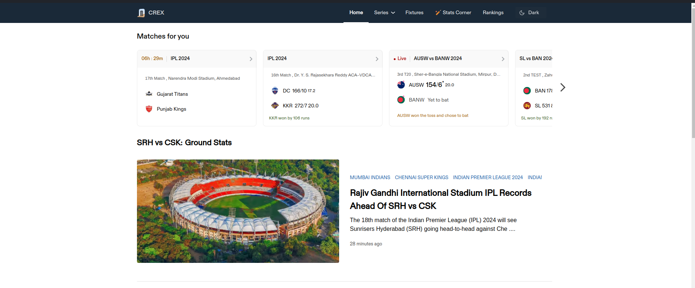
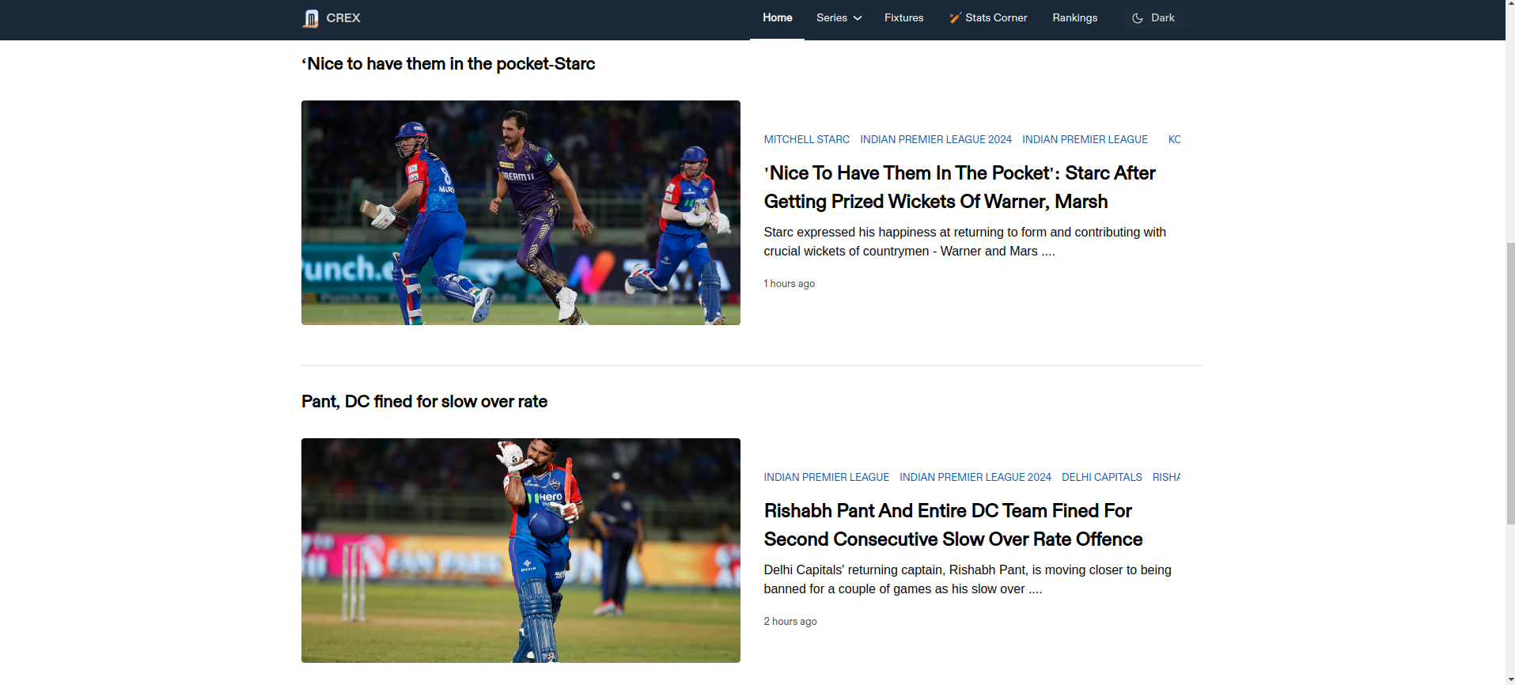

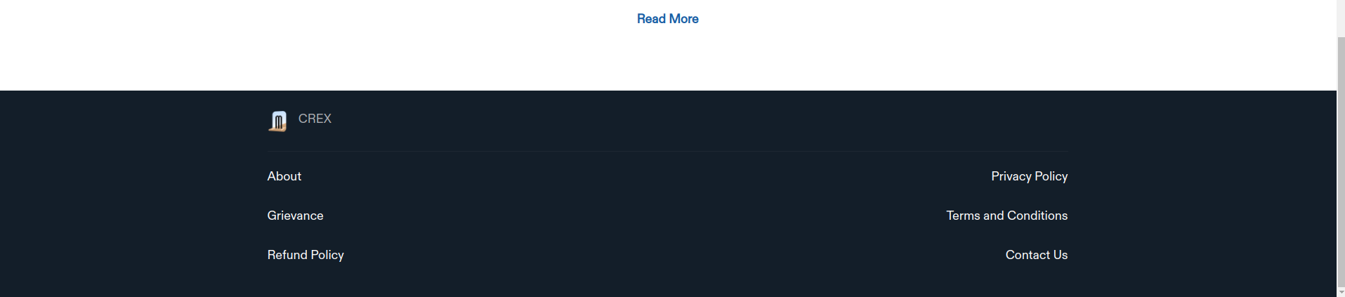

SERIES PANNEL

STATE CORNER

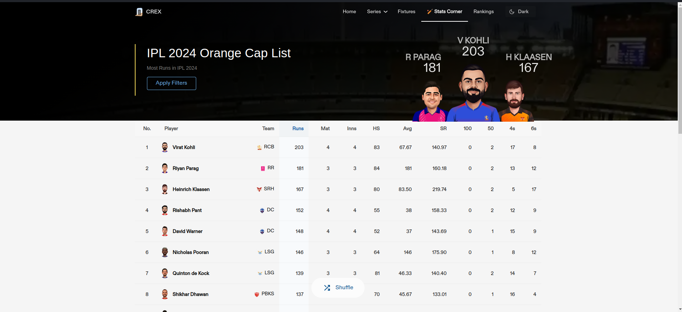
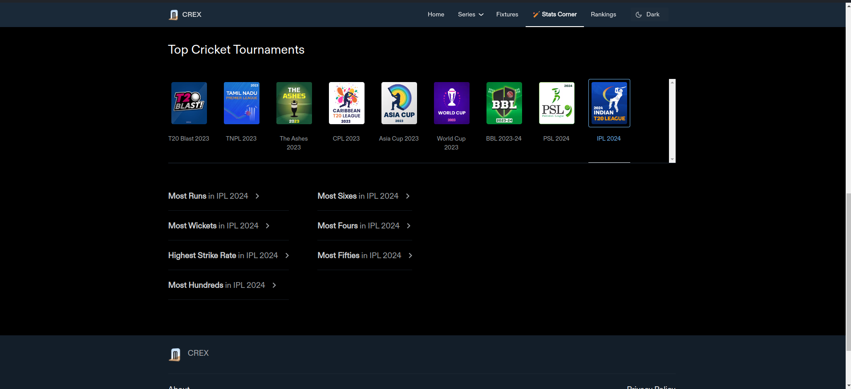

RANKING
